EXPERIMENT 3:
The stakeholders have conflicting views on the user interface design for an E-Commerce mobile app. Create a prototype using Figma tool to discuss with the stakeholders to get their feedback and approval.
Step 1: Login to Figma
- Open a web browser and navigate to https://www.figma.com.
- Sign in using your Figma account credentials.
- Click New Design File to create a new project.
Step 2: Create a Mobile Frame
- Select the Frame Tool (F).
- Choose a mobile device frame (e.g., iPhone 14 Plus).
- Create separate frames for each screen of the application.
Step 3: Design the Home Screen
- Add the application logo and title.
- Include a search bar and product categories.
- Display featured products with images, prices, and ratings.
- Add a bottom navigation bar.
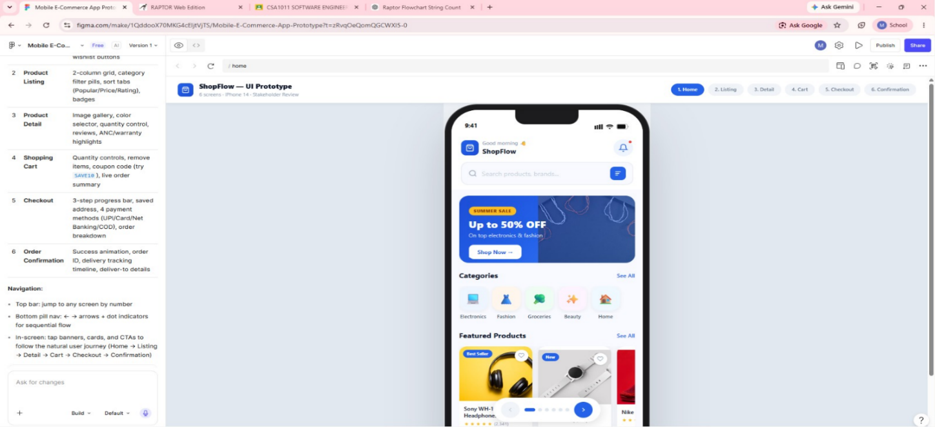
Step 4: Design the Product Details Screen
- Create a new frame.
- Display the product image, name, description, price, and customer ratings.
- Add Add to Cart and Buy Now buttons.
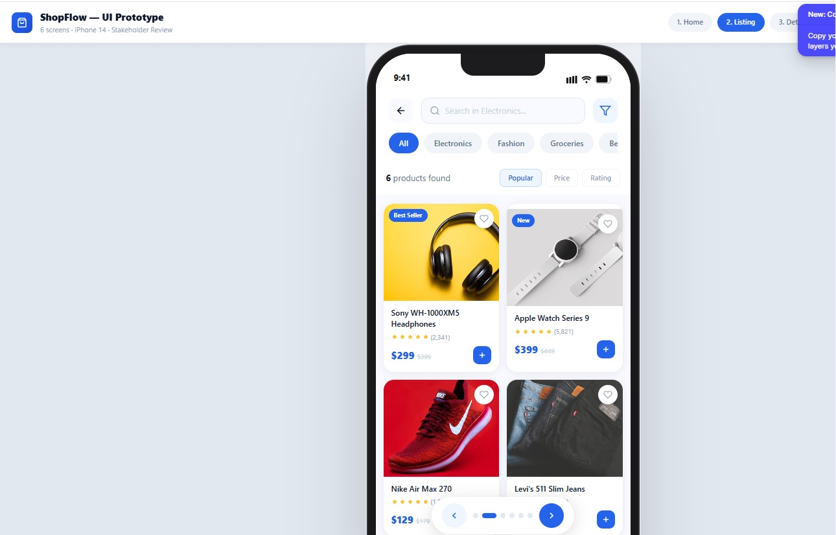
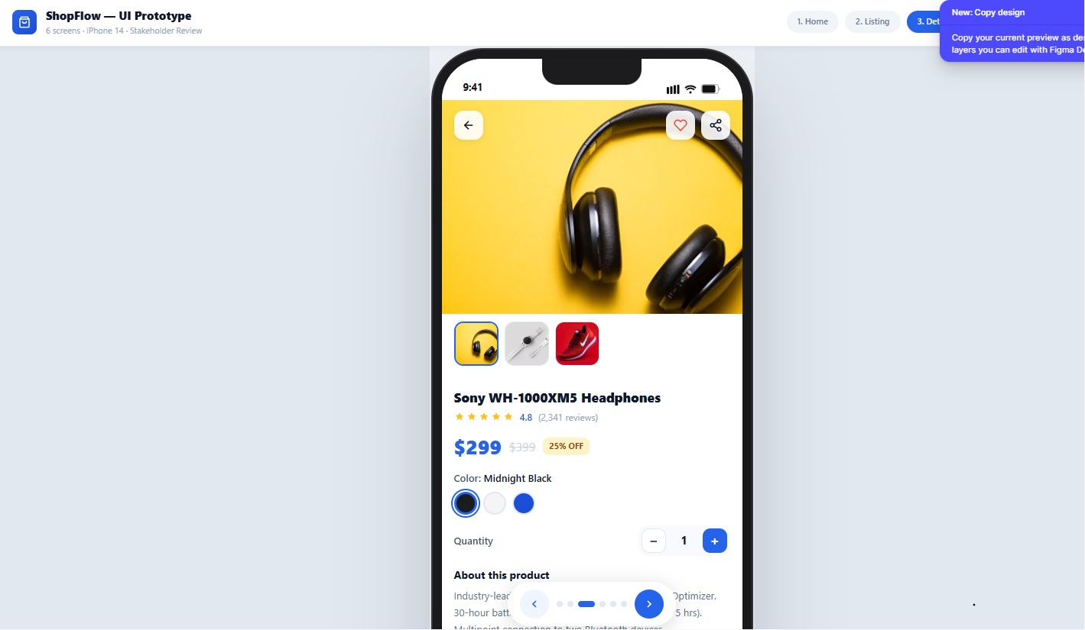
Step 5: Design the Shopping Cart Screen
- Create another frame.
- Display the selected products with quantity and price.
- Show the total amount.
- Add a Proceed to Checkout button.
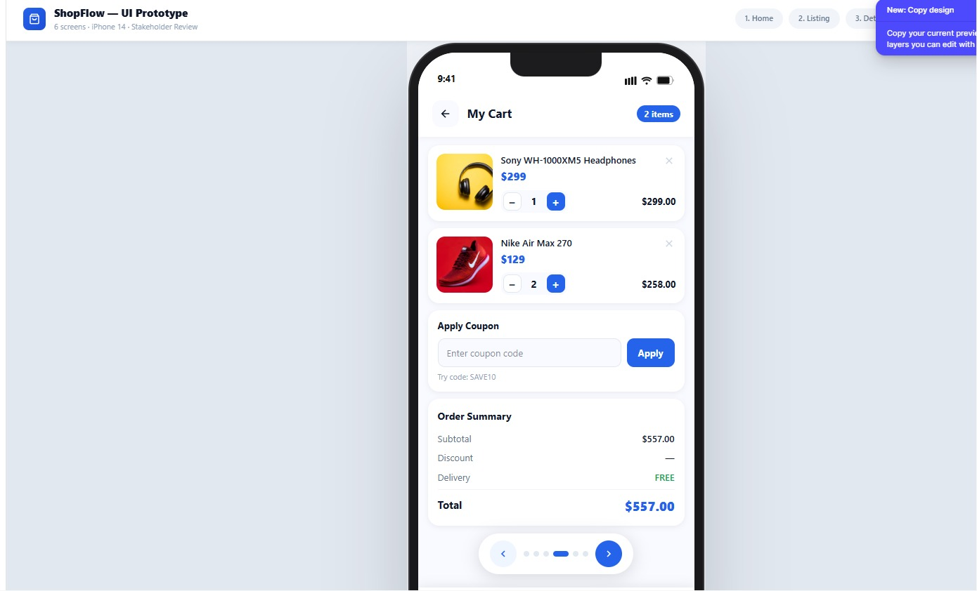

Step 6: Design the Checkout Screen
- Create a new frame.
- Add fields for delivery address, payment method, and order summary.
- Include a Place Order button.
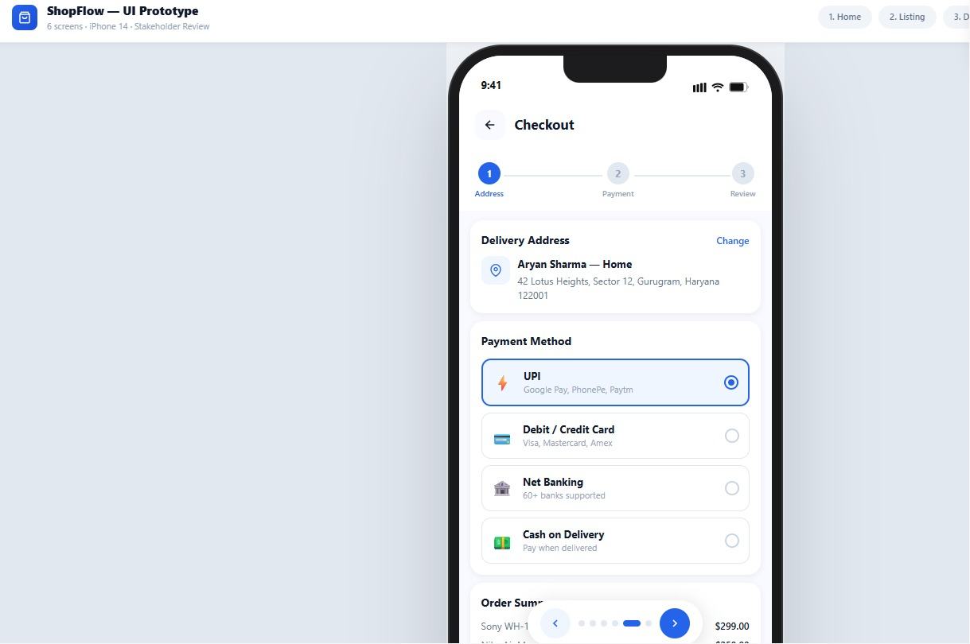
Step 7: Design the Order Confirmation Screen
- Create the final frame.
- Display a confirmation message with the order ID.
- Show the estimated delivery date.

- Add a Continue Shopping button.

Step 8: Create the Prototype
- Switch to the Prototype tab.
- Connect all screens using interaction arrows.
- Set the navigation flow from the Home Screen to the Order Confirmation Screen.
Step 9: Review the Prototype with Stakeholders
- Present the prototype using Present mode.
- Review the user interface with stakeholders.
- Collect feedback and note suggested improvements for the design.
Step 10: Update and Save the Prototype
- Modify the prototype based on stakeholder feedback.
- Save the updated Figma design.
- Capture screenshots of the final prototype for documentation and approval.

